**SECURE FILE STORAGE ON CLOUD USING HYBRID CRYPTOGRAPHY**

**Abstract**

In this paper we aim to securely store information into the cloud, by splitting data into several chunks and storing parts of it on cloud in a manner that preserves data confidentiality, integrity and ensures availability. The rapidly increased use of cloud computing in the many organization and IT industries provides new software with low cost. Cloud computing is beneficial in terms of low cost and accessibility of data. Cloud computing gives lot of benefits with low cost and of data accessibility through Internet. Ensuring the security of cloud computing is a major factor in the cloud computing environment, as users often store sensitive information with cloud storage providers, but these providers may be untrusted. So sharing data in secure manner while preserving data from an untrusted cloud is still a challenging issue. Our approach ensures the security and privacy of client sensitive information by storing data across single cloud, using AES, DES and RC2 algorithm.

**INTRODUCTION**

**What is cloud computing?**

**Cloud computing** is the use of [computing](http://en.wikipedia.org/wiki/Computing) resources (hardware and software) that are delivered as a service over a network (typically the [Internet](http://en.wikipedia.org/wiki/Internet)). The name comes from the common use of a cloud-shaped symbol as an abstraction for the complex infrastructure it contains in system diagrams. Cloud computing entrusts remote services with a user's data, software and computation. Cloud computing consists of hardware and software resources made available on the Internet as managed third-party services. These services typically provide access to advanced software applications and high-end networks of server computers.

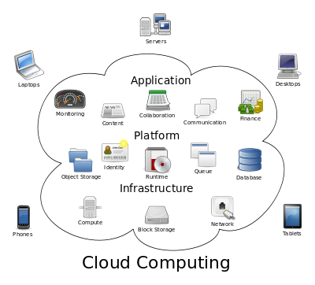

**Structure of cloud computing**

**How Cloud Computing Works?**

The goal of cloud computing is to apply traditional [supercomputing](http://www.webopedia.com/TERM/S/supercomputer.html), or [high-performance computing](http://www.webopedia.com/TERM/H/High_Performance_Computing.html) power, normally used by military and research facilities, to perform tens of trillions of computations per second, in consumer-oriented applications such as financial portfolios, to deliver personalized information, to provide data storage or to power large, immersive computer games.

The cloud computing uses [networks](http://www.webopedia.com/TERM/N/network.html) of large groups of [servers](http://www.webopedia.com/TERM/S/server.html) typically running low-cost consumer PC technology with specialized connections to spread data-processing chores across them. This shared [IT](http://www.webopedia.com/TERM/I/IT.html) infrastructure contains large pools of systems that are linked together. Often, [virtualization](http://www.webopedia.com/TERM/V/virtualization.html) techniques are used to maximize the power of cloud computing.

**Characteristics and Services Models:**

The salient characteristics of cloud computing based on the definitions provided by the National Institute of Standards and Terminology (NIST) are outlined below:

* **On-demand self-service**: A consumer can unilaterally provision computing capabilities, such as server time and network storage, as needed automatically without requiring human interaction with each service’s provider.
* **Broad network access**: Capabilities are available over the network and accessed through standard mechanisms that promote use by heterogeneous thin or thick client platforms (e.g., mobile phones, laptops, and PDAs).
* **Resource pooling**: The provider’s computing resources are pooled to serve multiple consumers using a multi-tenant model, with different physical and virtual resources dynamically assigned and reassigned according to consumer demand. There is a sense of location-independence in that the customer generally has no control or knowledge over the exact location of the provided resources but may be able to specify location at a higher level of abstraction (e.g., country, state, or data center). Examples of resources include storage, processing, memory, network bandwidth, and virtual machines.
* **Rapid elasticity**: Capabilities can be rapidly and elastically provisioned, in some cases automatically, to quickly scale out and rapidly released to quickly scale in. To the consumer, the capabilities available for provisioning often appear to be unlimited and can be purchased in any quantity at any time.
* **Measured service**: Cloud systems automatically control and optimize resource use by leveraging a metering capability at some level of abstraction appropriate to the type of service (e.g., storage, processing, bandwidth, and active user accounts). Resource usage can be managed, controlled, and reported providing transparency for both the provider and consumer of the utilized service.

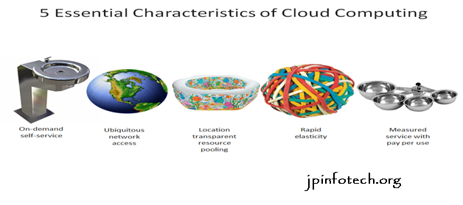

**Characteristics of cloud computing**

**Services Models:**

  Cloud Computing comprises three different service models, namely Infrastructure-as-a-Service (IaaS), Platform-as-a-Service (PaaS), and Software-as-a-Service (SaaS). The three service models or layer are completed by an end user layer that encapsulates the end user perspective on cloud services. The model is shown in figure below. If a cloud user accesses services on the infrastructure layer, for instance, she can run her own applications on the resources of a cloud infrastructure and remain responsible for the support, maintenance, and security of these applications herself. If she accesses a service on the application layer, these tasks are normally taken care of by the cloud service provider.

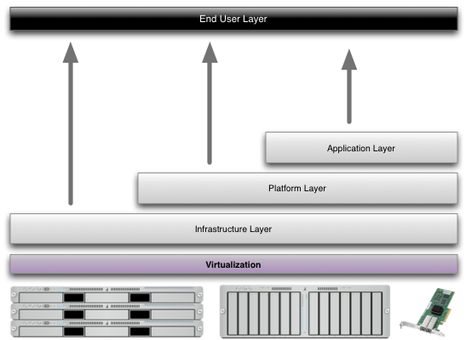

**Structure of service models**

**Benefits of cloud computing:**

1. **Achieve economies of scale** – increase volume output or productivity with fewer people. Your cost per unit, project or product plummets.
2. **Reduce spending on technology infrastructure.** Maintain easy access to your information with minimal upfront spending. Pay as you go (weekly, quarterly or yearly), based on demand.
3. **Globalize your workforce on the cheap.** People worldwide can access the cloud, provided they have an Internet connection.
4. **Streamline processes.** Get more work done in less time with less people.
5. **Reduce capital costs.** There’s no need to spend big money on hardware, software or licensing fees.
6. **Improve accessibility.** You have access anytime, anywhere, making your life so much easier!
7. **Monitor projects more effectively.** Stay within budget and ahead of completion cycle times.
8. **Less personnel training is needed.** It takes fewer people to do more work on a cloud, with a minimal learning curve on hardware and software issues.
9. **Minimize licensing new software.** Stretch and grow without the need to buy expensive software licenses or programs.
10. **Improve flexibility.** You can change direction without serious “people” or “financial” issues at stake.

**Advantages:**

1. **Price:** Pay for only the resources used.
2. **Security**: Cloud instances are isolated in the network from other instances for improved security.
3. **Performance:** Instances can be added instantly for improved performance. Clients have access to the total resources of the Cloud’s core hardware.
4. **Scalability:** Auto-deploy cloud instances when needed.
5. **Uptime:** Uses multiple servers for maximum redundancies. In case of server failure, instances can be automatically created on another server.
6. **Control:** Able to login from any location. Server snapshot and a software library lets you deploy custom instances.
7. **Traffic:** Deals with spike in traffic with quick deployment of additional instances to handle the load.

**LITERATURE SURVEY**

1. **Attribute-based fine-grained access control with efficient revocation in cloud storage systems**

**AUTHORS:**  Kan Yang, Xiaohua Jia, Kui Ren

A cloud storage service allows data owner to outsource their data to the cloud and through which provide the data access to the users. Because the cloud server and the data owner are not in the same trust domain, the semi-trusted cloud server cannot be relied to enforce the access policy. To address this challenge, traditional methods usually require the data owner to encrypt the data and deliver decryption keys to authorized users. These methods, however, normally involve complicated key management and high overhead on data owner. In this paper, we design an access control framework for cloud storage systems that achieves fine-grained access control based on an adapted Cipher text-Policy Attribute-based Encryption (CP-ABE) approach. In the proposed scheme, an efficient attribute revocation method is proposed to cope with the dynamic changes of users' access privileges in large-scale systems. The analysis shows that the proposed access control scheme is provably secure in the random oracle model and efficient to be applied into practice.

**2) Achieving Usable and Privacy-assured Similarity Search over Outsourced Cloud Data**

**AUTHORS:**  Cong Wang, Kui Ren, Shucheng Yu, and Karthik Mahendra Raje

As the data produced by individuals and enterprises that need to be stored and utilized are rapidly increasing, data owners are motivated to outsource their local complex data management systems into the cloud for its great flexibility and economic savings. However, as sensitive cloud data may have to be encrypted before outsourcing, which obsoletes the traditional data utilization service based on plaintext keyword search, how to enable privacy-assured utilization mechanisms for outsourced cloud data is thus of paramount importance. Considering the large number of on-demand data users and huge amount of outsourced data files in cloud, the problem is particularly challenging, as it is extremely difficult to meet also the practical requirements of performance, system usability, and high-level user searching experiences. In this paper, we investigate the problem of secure and efficient similarity search over outsourced cloud data. Similarity search is a fundamental and powerful tool widely used in plaintext information retrieval, but has not been quite explored in the encrypted data domain. Our mechanism design first exploits a suppressing technique to build storage-efficient similarity keyword set from a given document collection, with edit distance as the similarity metric. Based on that, we then build a private trie-traverse searching index, and show it correctly achieves the defined similarity search functionality with constant search time complexity. We formally prove the privacy-preserving guarantee of the proposed mechanism under rigorous security treatment. To demonstrate the generality of our mechanism and further enrich the application spectrum, we also show our new construction naturally supports fuzzy search, a previously studied notion aiming only to tolerate typos and representation inconsistencies in the user searching input. The extensive experiments on Amazon cloud platform with real data set further demonstrate the validity and practicality of the proposed mechanism.

1. **DACMACS: Effective Data Access Control for Multiauthority Cloud Storage Systems**

**AUTHORS:**  Kan Yang, Xiaohua Jia, Kui Ren, Bo Zhang, Ruitao Xie

Data access control is an effective way to ensure data security in the cloud. However, due to data outsourcing and untrusted cloud servers, the data access control becomes a challenging issue in cloud storage systems. Existing access control schemes are no longer applicable to cloud storage systems, because they either produce multiple encrypted copies of the same data or require a fully trusted cloud server. Ciphertext-policy attribute-based encryption (CP-ABE) is a promising technique for access control of encrypted data. However, due to the inefficiency of decryption and revocation, existing CP-ABE schemes cannot be directly applied to construct a data access control scheme for multiauthority cloud storage systems, where users may hold attributes from multiple authorities. In this paper, we propose data access control for multiauthority cloud storage (DAC-MACS), an effective and secure data access control scheme with efficient decryption and revocation. Specifically, we construct a new multiauthority CP-ABE scheme with efficient decryption, and also design an efficient attribute revocation method that can achieve both forward security and backward security. We further propose an extensive data access control scheme (EDAC-MACS), which is secure under weaker security assumptions.

# 4) Attribute based proxy re-encryption with delegating capabilities.

# AUTHORS: Liang Xiaohui, Cao Zhenfu, Lin Huang

Attribute based proxy re-encryption scheme (ABPRE) is a new cryptographic primitive which extends the traditional proxy re-encryption (public key or identity based cryptosystem) to the attribute based counterpart, and thus empower users with delegating capability in the access control environment. Users, identified by attributes, could freely designate a proxy who can re-encrypt a cipher text related with a certain access policy to another one with a different access policy. The proposed scheme is proved selective-structure chosen plaintext secure and master key secure without random oracles. Besides, we develop another kind of key delegating capability in our scheme and also discuss some related issues including a stronger security model and applications.

**5)** **Attribute based proxy re-encryption with delegating capabilities**

**AUTHORS:**  Liang Xiaohui, Cao Zhenfu, Lin Huang

Attribute based proxy re-encryption scheme (ABPRE) is a new cryptographic primitive which extends the traditional proxy re-encryption (public key or identity based cryptosystem) to the attribute based counterpart, and thus empower users with delegating capability in the access control environment. Users, identified by attributes, could freely designate a proxy who can re-encrypt a cipher text related with a certain access policy to another one with a different access policy. The proposed scheme is proved selective-structure chosen plaintext secure and master key secure without random oracles. Besides, we develop another kind of key delegating capability in our scheme and also discuss some related issues including a stronger security model and applications.

**SYSTEM ANALYSIS**

**EXISTING SYSTEM:**

* more data storage needs turning over to the cloud, finding a secure and efficient data access structure has become a major research issue
* Security techniques are not applied in the protection of offloaded data from attacks.
* Once uploaded and shared, the data owner inevitably loses control over the data, opening the door to unauthorized data access.

**PROPOSED SYSTEM:**

Selectively sharing data files on the cloud becomes a burden on the data owner as the hierarchy grows (the access privileges increase in number) and/or as the access restrictions become more complex due to an increase in the sensitivity of the file segments. A trivial solution involves the data owner to use public key encryption. This solution would require the data owner to encrypt the same part of the data file once for each data user being granted access then upload the resulting cipher texts to the cloud. The data users would then fetch their uniquely encrypted parts of the file from the cloud and utilize their private keys to decrypt them. This method ensures that no unprivileged data user will gain access to any part of the data file even if that user is able to download the cipher texts from the cloud. However, on a large scale, public key encryption becomes an inefficient solution due to the increase in the number of encryptions and large storage spaces required. Therefore, the challenge is to provide the data owners with an efficient, secure and privilege-based method that allows them to selectively share their data files among multiple data users while minimizing the required cloud storage space needed to store the encrypted data segments.

* Requiring less network communication.
* We present multiple data file partitioning techniques and propose a privilege-based access structure that facilitate data sharing in hierarchical settings.
* A new security layer is added to encrypt the data of the task before transferring to the cloud side by using AES encryption technique.

**SYSTEM REQUIREMENTS:**

**HARDWARE REQUIREMENTS:**

* System : Pentium IV 2.4 GHz.
* Hard Disk : 40 GB.
* Floppy Drive : 1.44 Mb.
* Monitor : 15 VGA Colour.
* Mouse : Logitech.
* Ram : 512 Mb.

**SOFTWARE REQUIREMENTS:**

* Operating system : - Windows XP/7.
* Coding Language : Python
* Data Base : MYSQL

**SOFTWARE ENVIRONMENT**

**Python** is a high-level, interpreted scripting language developed in the late 1980s by Guido van Rossum at the National Research Institute for Mathematics and Computer Science in the Netherlands. The initial version was published at the alt.sources newsgroup in 1991, and version 1.0 was released in 1994.

Python 2.0 was released in 2000, and the 2.x versions were the prevalent releases until December 2008. At that time, the development team made the decision to release version 3.0, which contained a few relatively small but significant changes that were not backward compatible with the 2.x versions. Python 2 and 3 are very similar, and some features of Python 3 have been back ported to Python 2. But in general, they remain not quite compatible.

Both Python 2 and 3 have continued to be maintained and developed, with periodic release updates for both. As of this writing, the most recent versions available are 2.7.15 and 3.6.5. However, an official End of Life date of January 1, 2020 has been established for Python 2, after which time it will no longer be maintained. If you are a newcomer to Python, it is recommended that you focus on Python 3, as this tutorial will do.

Python is still maintained by a core development team at the Institute, and Guido is still in charge, having been given the title of BDFL (Benevolent Dictator For Life) by the Python community. The name Python, by the way, derives not from the snake, but from the British comedy troupe Monty Python’s Flying Circus, of which Guido was, and presumably still is, a fan. It is common to find references to Monty Python sketches and movies scattered throughout the Python documentation.

**Why Choose Python?**

If you’re going to write programs, there are literally dozens of commonly used languages to choose from. Why choose Python? Here are some of the features that make Python an appealing choice.

Python is Popular

Python has been growing in popularity over the last few years. The 2018 Stack Overflow Developer Survey ranked Python as the 7th most popular and the number one most wanted technology of the year. World-class software development countries around the globe use Python every single day.

According to research by Dice Python is also one of the hottest skills to have and the most popular programming language in the world based on the Popularity of Programming Language Index.

Due to the popularity and widespread use of Python as a programming language, Python developers are sought after and paid well. If you’d like to dig deeper into Python salary statistics and job opportunities, you can do so here.

Python is interpreted

Many languages are compiled, meaning the source code you create needs to be translated into machine code, the language of your computer’s processor, before it can be run. Programs written in an interpreted language are passed straight to an interpreter that runs them directly.

This makes for a quicker development cycle because you just type in your code and run it, without the intermediate compilation step.

One potential downside to interpreted languages is execution speed. Programs that are compiled into the native language of the computer processor tend to run more quickly than interpreted programs. For some applications that are particularly computationally intensive, like graphics processing or intense number crunching, this can be limiting.

In practice, however, for most programs, the difference in execution speed is measured in milliseconds, or seconds at most, and not appreciably noticeable to a human user. The expediency of coding in an interpreted language is typically worth it for most applications.

### Python is Free

The Python interpreter is developed under an OSI-approved open-source license, making it free to install, use, and distribute, even for commercial purposes.

A version of the interpreter is available for virtually any platform there is, including all flavors of UNIX, Windows, macOS, smart phones and tablets, and probably anything else you ever heard of. A version even exists for the half dozen people remaining who use OS/2.

### Python is Portable

Because Python code is interpreted and not compiled into native machine instructions, code written for one platform will work on any other platform that has the Python interpreter installed. (This is true of any interpreted language, not just Python.)

### Python is Simple

As programming languages go, Python is relatively uncluttered, and the developers have deliberately kept it that way.

A rough estimate of the complexity of a language can be gleaned from the number of keywords or reserved words in the language. These are words that are reserved for special meaning by the compiler or interpreter because they designate specific built-in functionality of the language.

Python 3 has 33 keywords, and Python 2 has 31. By contrast, C++ has 62, Java has 53, and Visual Basic has more than 120, though these latter examples probably vary somewhat by implementation or dialect.

Python code has a simple and clean structure that is easy to learn and easy to read. In fact, as you will see, the language definition enforces code structure that is easy to read.

### But it’s Not That Simple

For all its syntactical simplicity, Python supports most constructs that would be expected in a very high-level language, including complex dynamic data types, structured and functional programming, and object-oriented programming.

Additionally, a very extensive library of classes and functions is available that provides capability well beyond what is built into the language, such as database manipulation or GUI programming.

Python accomplishes what many programming languages don’t: the language itself is simply designed, but it is very versatile in terms of what you can accomplish with it.

## Conclusion

This section gave an overview of the **Python** programming language, including:

* A brief history of the development of Python
* Some reasons why you might select Python as your language of choice

Python is a great option, whether you are a beginning programmer looking to learn the basics, an experienced programmer designing a large application, or anywhere in between. The basics of Python are easily grasped, and yet its capabilities are vast.

Proceed to the next section to learn how to acquire and install Python on your computer.

**Python** is an [open source](https://simple.wikipedia.org/wiki/Open_source) programming language that was made to be easy-to-read and powerful. A Dutch programmer named Guido van Rossum made Python in 1991. He named it after the television show Monty Python's Flying Circus. Many Python examples and tutorials include jokes from the show.

Python is an interpreted language. Interpreted languages do not need to be compiled to run. A program called an interpreter runs Python code on almost any kind of computer. This means that a programmer can change the code and quickly see the results. This also means Python is slower than a compiled language like C, because it is not running machine code directly.

Python is a good programming language for beginners. It is a high-level language, which means a programmer can focus on what to do instead of how to do it. Writing programs in Python takes less time than in some other languages.

Python drew inspiration from other programming languages like C, C++, Java, Perl, and Lisp.

Python has a very easy-to-read syntax. Some of Python's syntax comes from C, because that is the language that Python was written in. But Python uses whitespace to delimit code: spaces or tabs are used to organize code into groups. This is different from C. In C, there is a semicolon at the end of each line and curly braces ({}) are used to group code. Using whitespace to delimit code makes Python a very easy-to-read language.

**Python use:**

Python is used by hundreds of thousands of programmers and is used in many places. Sometimes only Python code is used for a program, but most of the time it is used to do simple jobs while another programming language is used to do more complicated tasks.

Its standard library is made up of many functions that come with Python when it is installed. On the Internet there are many other libraries available that make it possible for the Python language to do more things. These libraries make it a powerful language; it can do many different things.

Some things that Python is often used for are:

* Web development
* Scientific programming
* Desktop GUIs
* Network programming
* Game programming

**SYSTEM DESIGN**

**INPUT DESIGN**

The input design is the link between the information system and the user. It comprises the developing specification and procedures for data preparation and those steps are necessary to put transaction data in to a usable form for processing can be achieved by inspecting the computer to read data from a written or printed document or it can occur by having people keying the data directly into the system. The design of input focuses on controlling the amount of input required, controlling the errors, avoiding delay, avoiding extra steps and keeping the process simple. The input is designed in such a way so that it provides security and ease of use with retaining the privacy. Input Design considered the following things:

* What data should be given as input?
* How the data should be arranged or coded?
* The dialog to guide the operating personnel in providing input.
* Methods for preparing input validations and steps to follow when error occur.

**OBJECTIVES**

1. Input Design is the process of converting a user-oriented description of the input into a computer-based system. This design is important to avoid errors in the data input process and show the correct direction to the management for getting correct information from the computerized system.

2. It is achieved by creating user-friendly screens for the data entry to handle large volume of data. The goal of designing input is to make data entry easier and to be free from errors. The data entry screen is designed in such a way that all the data manipulates can be performed. It also provides record viewing facilities.

3. When the data is entered it will check for its validity. Data can be entered with the help of screens. Appropriate messages are provided as when needed so that the user will not be in maize of instant. Thus the objective of input design is to create an input layout that is easy to follow

**OUTPUT DESIGN**

A quality output is one, which meets the requirements of the end user and presents the information clearly. In any system results of processing are communicated to the users and to other system through outputs. In output design it is determined how the information is to be displaced for immediate need and also the hard copy output. It is the most important and direct source information to the user. Efficient and intelligent output design improves the system’s relationship to help user decision-making.

1. Designing computer output should proceed in an organized, well thought out manner; the right output must be developed while ensuring that each output element is designed so that people will find the system can use easily and effectively. When analysis design computer output, they should Identify the specific output that is needed to meet the requirements.

2. Select methods for presenting information.

3. Create document, report, or other formats that contain information produced by the system.

The output form of an information system should accomplish one or more of the following objectives.

* Convey information about past activities, current status or projections of the
* Future.
* Signal important events, opportunities, problems, or warnings.
* Trigger an action.
* Confirm an action.

**SYSTEM ARCHITECTURE:**

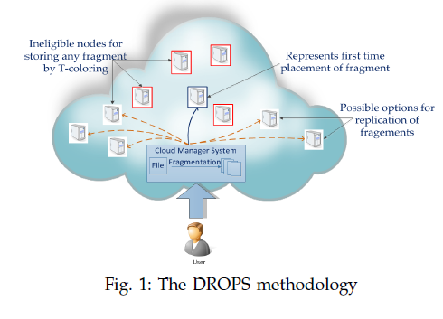

**DATA FLOW DIAGRAM:**

1. The DFD is also called as bubble chart. It is a simple graphical formalism that can be used to represent a system in terms of input data to the system, various processing carried out on this data, and the output data is generated by this system.
2. The data flow diagram (DFD) is one of the most important modeling tools. It is used to model the system components. These components are the system process, the data used by the process, an external entity that interacts with the system and the information flows in the system.
3. DFD shows how the information moves through the system and how it is modified by a series of transformations. It is a graphical technique that depicts information flow and the transformations that are applied as data moves from input to output.
4. DFD is also known as bubble chart. A DFD may be used to represent a system at any level of abstraction. DFD may be partitioned into levels that represent increasing information flow and functional detail.

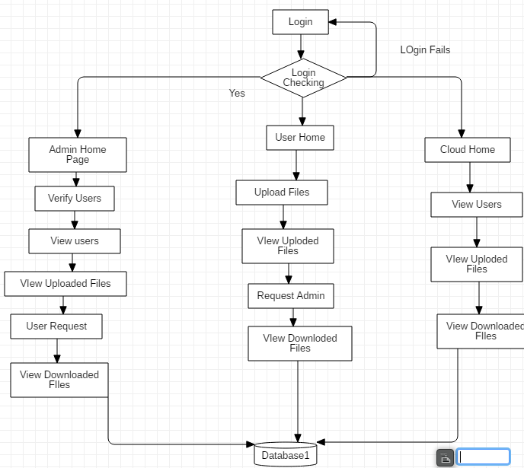

**UML DIAGRAMS**

UML stands for Unified Modeling Language. UML is a standardized general-purpose modeling language in the field of object-oriented software engineering. The standard is managed, and was created by, the Object Management Group.

The goal is for UML to become a common language for creating models of object oriented computer software. In its current form UML is comprised of two major components: a Meta-model and a notation. In the future, some form of method or process may also be added to; or associated with, UML.

The Unified Modeling Language is a standard language for specifying, Visualization, Constructing and documenting the artifacts of software system, as well as for business modeling and other non-software systems.

The UML represents a collection of best engineering practices that have proven successful in the modeling of large and complex systems.

The UML is a very important part of developing objects oriented software and the software development process. The UML uses mostly graphical notations to express the design of software projects.

**GOALS:**

The Primary goals in the design of the UML are as follows:

1. Provide users a ready-to-use, expressive visual modeling Language so that they can develop and exchange meaningful models.
2. Provide extendibility and specialization mechanisms to extend the core concepts.
3. Be independent of particular programming languages and development process.
4. Provide a formal basis for understanding the modeling language.
5. Encourage the growth of OO tools market.
6. Support higher level development concepts such as collaborations, frameworks, patterns and components.
7. Integrate best practices.

**USE CASE DIAGRAM:**

A use case diagram in the Unified Modeling Language (UML) is a type of behavioral diagram defined by and created from a Use-case analysis. Its purpose is to present a graphical overview of the functionality provided by a system in terms of actors, their goals (represented as use cases), and any dependencies between those use cases. The main purpose of a use case diagram is to show what system functions are performed for which actor. Roles of the actors in the system can be depicted.

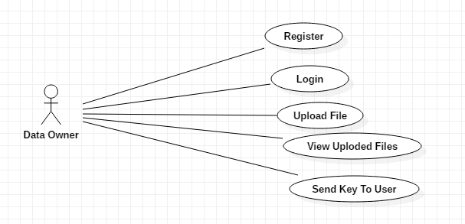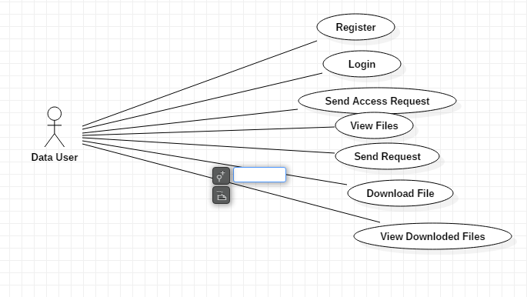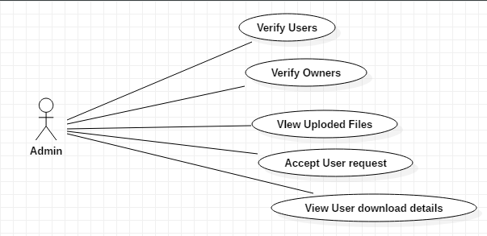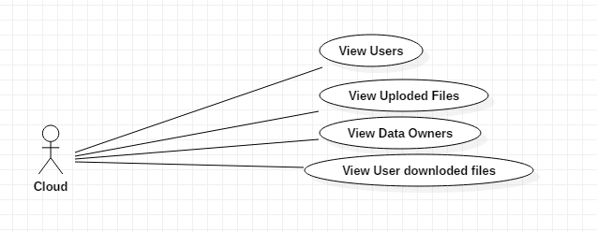

**CLASS DIAGRAM:**

In software engineering, a class diagram in the Unified Modeling Language (UML) is a type of static structure diagram that describes the structure of a system by showing the system's classes, their attributes, operations (or methods), and the relationships among the classes. It explains which class contains information.

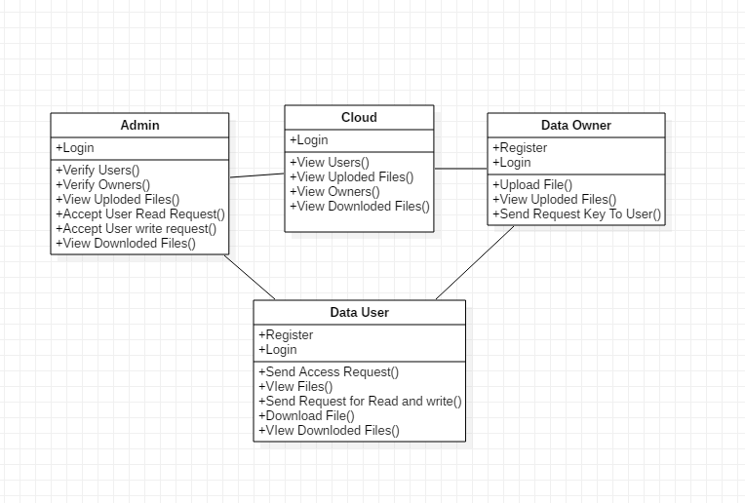

**SEQUENCE DIAGRAM:**

A sequence diagram in Unified Modeling Language (UML) is a kind of interaction diagram that shows how processes operate with one another and in what order. It is a construct of a Message Sequence Chart. Sequence diagrams are sometimes called event diagrams, event scenarios, and timing diagrams.

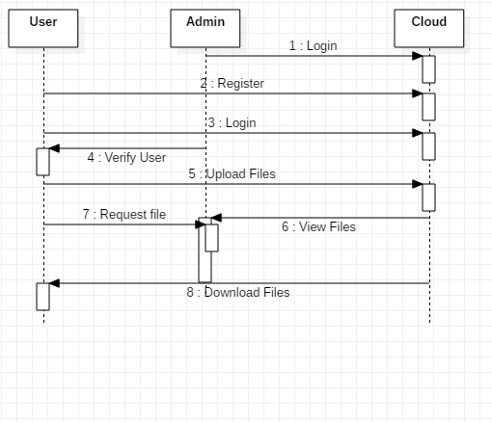

**ACTIVITY DIAGRAM:**

Activity diagrams are graphical representations of workflows of stepwise activities and actions with support for choice, iteration and concurrency. In the Unified Modeling Language, activity diagrams can be used to describe the business and operational step-by-step workflows of components in a system. An activity diagram shows the overall flow of control.

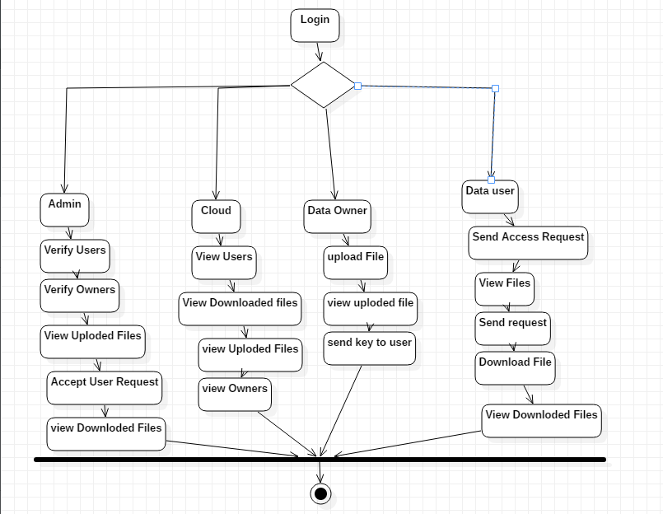

**IMPLEMENTATION AND RESULT**

**IMPLEMENTATION:**

**MODULES:**

* Data Owner
* Data User
* Admin
* Cloud

**MODULES DESCRIPTION:**

**Data Owner (DO):**

1. Data owner (DO) registers.

2. Login

3. Upload Files.

4. View Uploaded Files.

5. View User Read Request.

6. View User Write Request.

7. View Download File details

**Data User (DU):**

1. Register.
2. Login
3. Send Access Request.
4. View Files
5. Send Read Request.
6. View File.
7. Download Files.

**Cloud:**

1. Login
2. View Uploaded files.
3. View Downloaded files
4. View Downloaded Files.
5. View users
6. View Data Owners

**Admin:**

1. Login
2. Verify Users.
3. Verify Owners.
4. View Uploaded files
5. Verify User read request.
6. Verify User write Request.

**SYSTEM STUDY**

**FEASIBILITY STUDY**

The feasibility of the project is analyzed in this phase and business proposal is put forth with a very general plan for the project and some cost estimates. During system analysis the feasibility study of the proposed system is to be carried out. This is to ensure that the proposed system is not a burden to the company. For feasibility analysis, some understanding of the major requirements for the system is essential.

Three key considerations involved in the feasibility analysis are

* ECONOMICAL FEASIBILITY
* TECHNICAL FEASIBILITY
* SOCIAL FEASIBILITY

**ECONOMICAL FEASIBILITY**

This study is carried out to check the economic impact that the system will have on the organization. The amount of fund that the company can pour into the research and development of the system is limited. The expenditures must be justified. Thus the developed system as well within the budget and this was achieved because most of the technologies used are freely available. Only the customized products had to be purchased.

### TECHNICAL FEASIBILITY

This study is carried out to check the technical feasibility, that is, the technical requirements of the system. Any system developed must not have a high demand on the available technical resources. This will lead to high demands on the available technical resources. This will lead to high demands being placed on the client. The developed system must have a modest requirement, as only minimal or null changes are required for implementing this system.

**SOCIAL FEASIBILITY**

The aspect of study is to check the level of acceptance of the system by the user. This includes the process of training the user to use the system efficiently. The user must not feel threatened by the system, instead must accept it as a necessity. The level of acceptance by the users solely depends on the methods that are employed to educate the user about the system and to make him familiar with it. His level of confidence must be raised so that he is also able to make some constructive criticism, which is welcomed, as he is the final user of the system.

### SYSTEM TESTING

The purpose of testing is to discover errors. Testing is the process of trying to discover every conceivable fault or weakness in a work product. It provides a way to check the functionality of components, sub assemblies, assemblies and/or a finished product It is the process of exercising software with the intent of ensuring that the

Software system meets its requirements and user expectations and does not fail in an unacceptable manner. There are various types of test. Each test type addresses a specific testing requirement.

**TYPES OF TESTS**

**Unit testing**

Unit testing involves the design of test cases that validate that the internal program logic is functioning properly, and that program inputs produce valid outputs. All decision branches and internal code flow should be validated. It is the testing of individual software units of the application .it is done after the completion of an individual unit before integration. This is a structural testing, that relies on knowledge of its construction and is invasive. Unit tests perform basic tests at component level and test a specific business process, application, and/or system configuration. Unit tests ensure that each unique path of a business process performs accurately to the documented specifications and contains clearly defined inputs and expected results.

**Integration testing**

Integration tests are designed to test integrated software components to determine if they actually run as one program. Testing is event driven and is more concerned with the basic outcome of screens or fields. Integration tests demonstrate that although the components were individually satisfaction, as shown by successfully unit testing, the combination of components is correct and consistent. Integration testing is specifically aimed at exposing the problems that arise from the combination of components.

**Functional test**

Functional tests provide systematic demonstrations that functions tested are available as specified by the business and technical requirements, system documentation, and user manuals.

Functional testing is centered on the following items:

Valid Input : identified classes of valid input must be accepted.

Invalid Input : identified classes of invalid input must be rejected.

Functions : identified functions must be exercised.

Output : identified classes of application outputs must be exercised.

Systems/Procedures: interfacing systems or procedures must be invoked.

Organization and preparation of functional tests is focused on requirements, key functions, or special test cases. In addition, systematic coverage pertaining to identify Business process flows; data fields, predefined processes, and successive processes must be considered for testing. Before functional testing is complete, additional tests are identified and the effective value of current tests is determined.

**System Test**

System testing ensures that the entire integrated software system meets requirements. It tests a configuration to ensure known and predictable results. An example of system testing is the configuration oriented system integration test. System testing is based on process descriptions and flows, emphasizing pre-driven process links and integration points.

**White Box Testing**

White Box Testing is a testing in which in which the software tester has knowledge of the inner workings, structure and language of the software, or at least its purpose. It is purpose. It is used to test areas that cannot be reached from a black box level.

**Black Box Testing**

Black Box Testing is testing the software without any knowledge of the inner workings, structure or language of the module being tested. Black box tests, as most other kinds of tests, must be written from a definitive source document, such as specification or requirements document, such as specification or requirements document. It is a testing in which the software under test is treated, as a black box .you cannot “see” into it. The test provides inputs and responds to outputs without considering how the software works.

**6.1 Unit Testing:**

Unit testing is usually conducted as part of a combined code and unit test phase of the software lifecycle, although it is not uncommon for coding and unit testing to be conducted as two distinct phases.

**Test strategy and approach**

Field testing will be performed manually and functional tests will be written in detail.

**Test objectives**

* All field entries must work properly.
* Pages must be activated from the identified link.
* The entry screen, messages and responses must not be delayed.

**Features to be tested**

* Verify that the entries are of the correct format
* No duplicate entries should be allowed
* All links should take the user to the correct page.

# 6.2 Integration Testing

Software integration testing is the incremental integration testing of two or more integrated software components on a single platform to produce failures caused by interface defects.

The task of the integration test is to check that components or software applications, e.g. components in a software system or – one step up – software applications at the company level – interact without error.

**Test Results:** All the test cases mentioned above passed successfully. No defects encountered.

**6.3 Acceptance Testing**

User Acceptance Testing is a critical phase of any project and requires significant participation by the end user. It also ensures that the system meets the functional requirements.

**Test Results:** All the test cases mentioned above passed successfully. No defects encountered.

**CONCLUSION**

The numerous beneﬁts provided by the cloud have driven many large multilevel organizations to store and share their data on it. This paper begins by pointing out major security concerns data owners have when sharing their data on the cloud. Next, the most widely implemented and researched data sharing schemes are brieﬂy discussed revealing points of weakness in each. To address the concerns, this paper proposes a Privilege-based Multilevel Organizational Data sharing scheme (P-MOD) that allows data to be shared efficiently and securely on the cloud. P-MOD partitions a data ﬁle into multiple segments based on user privileges and data sensitivity. Each segment of the data ﬁle is then shared depending on data user privileges. We formally prove that P-MOD is secure against adaptively chosen plaintext attack assuming that the DBDH assumption holds. Our comprehensive performance and simulation comparisons with the three most representative schemes show that P-MOD cans signiﬁcantly reduce the computational complexity while minimizing the storage space. Our proposed scheme lays a foundation for future attribute-based, secure data management and smart contract development.

**REFERENCES**

* Y. Yang, X. Liu, R.H. Deng, “Multi-user Multi-Keyword Rank Search over Encrypted Data in Arbitrary Language”. IEEE Transactions on Dependable and Secure Computing, 2018, publish online, DOI: 10.1109/TDSC.2017.2787588.
* W. Sun, S. Yu, W. Lou, Y. Hou and H. Li, “Protecting Your Right: Verifiable Attribute-based Keyword Search with Fine-grained
* Owner-enforced Search Authorization in the Cloud,” IEEE Transactions on Parallel and Distributed Systems, 2016, vol. 27, no. 4, pp. 1187-1198.
* K. Liang, W. Susilo, “Searchable Attribute-Based Mechanism with Efficient Data Sharing for Secure Cloud Storage,” IEEE Transactions on Information Forensics and Security, 2015, vol. 10, no. 9, pp. 1981- 1992.
* M. Green, S. Hohenberger, and B.Waters, “Outsourcing the decryption of ABE ciphertexts,” in USENIX Security Symposium, ACM, 2011, pp. 34-34.
* J. Lai, R. H. Deng, C. Guan, and J. Weng, “Attribute-based encryption with verifiable outsourced decryption,” IEEE Transactions on Information Forensics and Security, 2013, vol. 8, no. 8, pp. 1343- 1354.
* B. Qin, R. H. Deng, S. Liu, and S. Ma, “Attribute-Based Encryption with Efficient Verifiable Outsourced Decryption,” IEEE Transactions on Information Forensics and Security, 2015, vol. 10, no. 7, pp. 1384-1394.
* D. Boneh, G. D. Crescenzo, R. Ostrovsky, and G. Persiano, “Public key encryption with keyword search,” in: EUROCRYPT, 2004, pp. 506-522.
* [13] Z. Liu, Z. Cao, D.S. Wong, “White-box traceable cipher text-policy attribute-based encryption supporting any monotone access structures,”IEEE Transactions on Information Forensics and Security, 2013, vol. 8, no. 1, pp. 76-88.